Bridgeport News
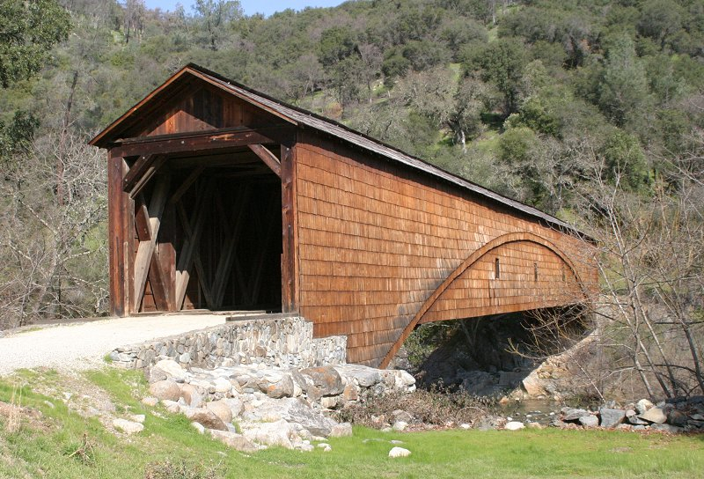
In This Issue
President’s Message | Pg 1
Class of 2010 Volunteers | Pg 2
California Preservation  Foundation Conference | Pg 2
Visitor Center | Pg 2
Beautification Committee | Pg 2
Gas Station Project Update | Pg 3
Trees and Shrubs  Trail Guide | Pg 3
Spring Festival | Pg 3
Business Sponsorship | Pg 3
Thanks to Contributors | Pg 4
Patty Pauly Remembrance | Pg 4
Anthony House Landmark | Pg 4
Brief Calendar
Point Defiance Loop Wildflower Walks
March 26, April 9, April 30 at 10 am, May 14 at 4 pm; North Parking Lot
Anthony House Plaque Dedication
April 23, 11 am at LWW dam overlook.
Spring Festival – Sunday, April 25,
10 am to 4 pm at Bridgeport.
California Preservation Conference
May 12-15, 2010 Details:
http://www.californiapreservation.org/about_2010.shtml
South Yuba River State Park
South Yuba River Park Association
President’s Message
Volume 2, Number 1 March 2010

As this newsletter is being published we are just a few days from the spring season. This is always an exciting season for volunteers and visitors alike. The start of daylight savings time, spring flowers, more sunny days, and warmer temperatures are a reminder that it is the season to spend more time outdoors.
This year will be an especially busy and exciting year at the Park. Some of the major activities include the start of construction of the gas station project, preparing for the California Preservation Foundation Conference, completing the Trees and Shrubs trail guide, staging the Spring Festival, raising funds through business sponsorships, and providing more assistance to the State Park employees.
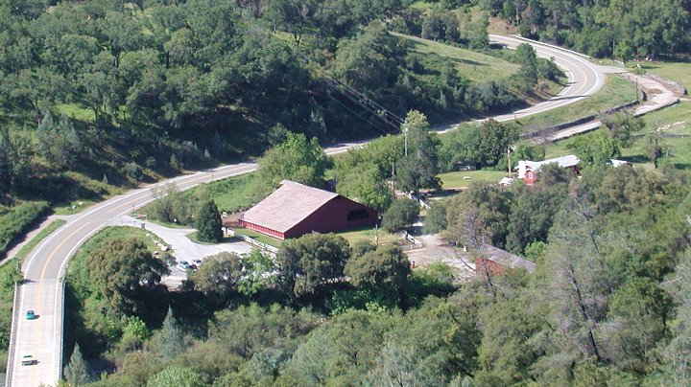
Bridgeport from Independence Loop Hill
The next fiscal year’s funding of the State Parks is very much up in the air. One effort to solve the funding is being lead by the California State Parks Foundation under the name of “State Parks and Wildlife Conservation Trust Fund Act of 2010”. Instead of facing an uncertain budget each year, the parks would be funded through trust fund revenues. The revenues would come from an $18 annual State Park 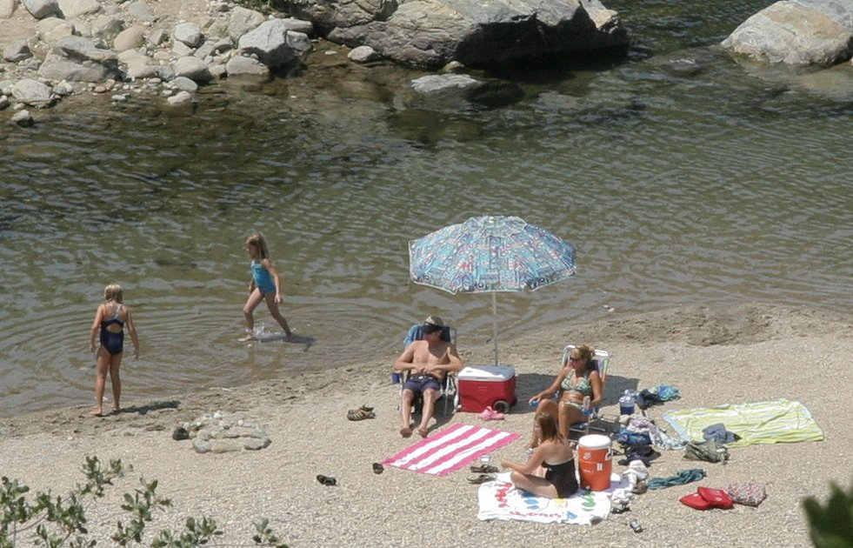
Spring is here, summer is soon
Access Pass Surcharge on all California cars, motorcycles and recreational vehicles, collected by DMV as part of the annual vehicle license fee. Currently, signatures are being collected to support this initiative. If the initiative is approved and if it receives a winning vote on the November election, the State Park’s future funding would be ensured.
March is the month for meeting and training new volunteers. We are always happy to see new faces and new talents. With that in mind we still need your help in finding volunteers to assume the functions of treasurer and publicity coordinator. If you have not done this before, don’t worry, we are happy to train and guide you in these tasks.
Ron Ernst

The California Preservation Foundation Conference
May 12-15, 2010
Class of 2010 —
New Volunteers
By Don Denton
The March 7th turnout at the Visitor Center for our third annual Reception for Prospective Docents was most gratifying, with 23 in attendance plus four more unable to attend but indicating interest — hallelujah! For the first time in three years, instead of a downpour Mother Nature blessed us with a crystal clear blue sky, which enabled the invitees to be seated outdoors.
One dozen SYRSP docents high-lighted various activities here at Bridgeport. After the 90-minute program the docents-to-be turned in their interest survey sheets on which they indicated their primary interests (e.g., gold panning, tour guides, natural history, and so on).
By the time you read this the “class of 2010” will have completed their three-park sector training at Empire Mine and will be in the middle of their three-Saturday-morning Bridgeport sessions right here in “River City.”
As was true from the last two class years, our park has garnered some really fine folks to wear our docent jacket and badge this year, and it looks like we’ll also have the quantity we need on top of the quality, so all-in-all it appears we will have another banner year at Bridgeport.
P.S. Many thanks to Marlene Katz (class of 2009), who assisted on both making calls and taking registration, as well as heading up the hospitality part, with cookies and coffee from fellow volunteers here, and to our dozen (actually 14) “five minute message” docents who gave our ‘rookies’ a fine sample of what we’re “up to” at the South Yuba River State Park.
Stay informed, use our website:
http://www.southyubariverstatepark.org
Gas Station Project Update
By George Case
Your SYRPA Board has approved an expenditure of $30,550 for Restoration of the Historic Shell Gas Station and Store. Our State Park District has assigned Pete "Ace" Flewelling to manage and participate in the restoration portion of this project. "Ace" is the wonderful craftsman who has worked in restoring and maintaining both the Covered Bridge and, most recently, our Historic Barn. The district will help supply the material needed to complete the project, thanks to Ranger Jeremy McReynolds.
This special project has a great team of docents working on fund raising and grant applications to Shell Oil and the State Parks Foundation. Thank you to Hal Tiegs, Paula and Charlie Bertness and Robin and Gary Eckhardt. Ranger Jeremy has scheduled a meeting to prepare and plan for the construction portion of this project on Tuesday, March 30th. The actual starting date of the construction phase will be Monday, April 5th. Docents interested in working on this exciting project should contact either Bill Haselhorst at 274-8007 or George Case at 432-2665.
Trees & Shrubs Trail Guide
By Steve Pauly
Posts have been installed along the Buttermilk Bend Trail to identify 24 tree and shrub species. Self-Guided Trail Guides are available at the trailhead in the North Parking Lot. An iron ranger is being installed nearby to collect suggested donations.
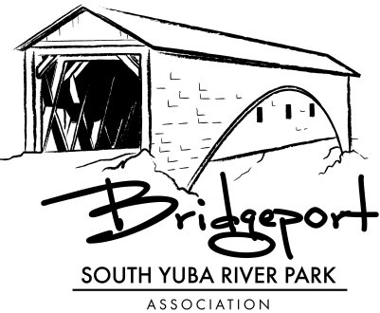

By Diane Marten
Volume 2, Number 1 Page 2
As many of you know, Nevada County has been chosen as the site for the 35th annual California Historic Preservation Conference to be held May 13-15 of this year. To our great delight, Bridgeport has been chosen as a destination for an exclusive tour and location for an in-depth study by the attendees. Many of us will be needed to help prepare and assist in this Confer-ence both at Bridgeport and at Convention headquarters in the Miner's Foundry, as well as various locations around Grass Valley. If you are interested in helping with conference registration, audio-visual set ups or for just welcoming and directing our guests to the various conference venues and places of interest, please let me know by sending me your name, phone number and email. The Preservation Foundation will conduct several short training sessions in April just to get us all organized and properly tuned up for this exciting event. So mark your calendars and let us know how and where you would like to participate. Please call or email Diane Marten at 432-5012.
What's Happening at the Visitor's Center
Visitor Center Operation Team
Have you visited our Visitor's Center recently? If not, take a break from your day's activities, come down to the park and stop in at the Visitor's Center. There is new merchandise—we have new spring tee shirts for women and men with our new Bridgeport logo. We also have white polo shirts with the logo stitched on the shirts (one can also special order colored polo shirts with the logo). We have three new children's books in addition to pocket activity books and a work book on the Gold Rush for children. We have new greeting cards featuring our wildflowers, book markers also with our wildflowers and bridge (a very popular item), and note cards with the bridge in black-and-white sketch form, and framed pictures of the bridge. California State Park whistles with a compass and light are also available. There is something new for everyone, so come on down and drop by the Visitor's Center. You may want to also take a walk along the Buttermilk Bend Trail and see the wildflowers and enjoy the roar of the river.
The Beautification Committee
By Mickey Springer
Bridgeport is emerging from its dormant stage and nature is showing its first signs of Spring. Wildflowers are already appearing everywhere, some of the Paperwhites in the Native Plant Garden are already history, trees are wanting to break into foliage, and, with the first signs of warm weather those annoying weeds are looking healthier than ever! That's my signal to get out there and do something about them, particularly in the NPG. Actually, there is more to do than some weeding around the park. The bulletin boards need
to be updated and reworked, the overgrowth around the gas station needs clearing so George Case and his group can begin their restoration, and the exterior to the VC fireplace needs a new coat of paint. Shortly, I'll be sending out an email asking for a work crew to take care of these areas. There is a deadline to complete these projects: April 25 is the Spring Festival, followed soon by the California Preservation Foundation Conference May 13-15. With your help for a few hours, one nice day will transform the park. Look for my email coming soon. As with past work crews, you will be rewarded with a lunch and some camaraderie with fellow docents.
Past work is evident at the park: one can now see the river (high) from the Native Plant Garden, and hear its sounds. Much of the pesky blackberry bushes have been eliminated, allowing the natural beauty of the park to stand out. Your continued willingness to spend a few hours to spruce up our park shows; I can't thank you enough for your continued help with these projects.
Volume 2, Number 1 Page 3
Spring Festival
By Roberta Canier
Within a blink of the eye our Spring Festival is upon us, and on April 25, at South Yuba River State Park, we will host another outstanding event featuring Living History Characters. Because SYRPA is host to the most wonderful band of docents, this event is well past the "to be planned stage" and is ready to be rolled out. (And a special thanks to Jean Wilson, who has been the major person in contacting people because of my personal situation.)
It is rumored that David Woods, as well as our favorite Indian Woman, are paying visits. Also on hand will be the Mountain Men, the pioneer woman wool spinner, and our 49er. Of course what would a Living History Day be without Alfred Kneebone managing his gas station. Wildflower crafts, barn tours, gold panning, wagon rides, blacksmith demonstrations and face painting are all offered to the day's enjoyment. Let's not forget food, again sold by the Penn Valley Chamber of Commerce and the Big Dipper. Round the day out with 3 venues of music, including Bite the Bullet and Emily Brockway, both back by popular demand.
This year we will have short tours to visit the history characters. A script is being written by LRC, so we need 7 volunteers here as well as our usual greeters, parking lot attendants and gofers. The gold panning and barn assignments have already been completed. Please call Roberta at (530) 320-4743 to throw your name into the volunteer pot. See the E-mail sent out re: these needs.
Thanks again for all of the Board's help in promoting Living History Day.
Brochure for Business Sponsorship
By Dave Anderson
The Association now has two new classes of membership. In addition to our traditional annual and lifetime individual or family memberships, we are now expanding our interest to area businesses willing to support our
Park. These business sponsorships are divided into two categories, one for larger businesses with more than five employees and the other for smaller businesses. Participation of members of our business community will enhance local awareness of our wonderful park and its mission and encourage their participation in our events. In return, their sponsorship will be recognized in our newsletter, on our website and at special events. Our Visitor Center Docents will have a binder providing information about those sponsors to relay to visitors who ask. Our sponsors will also be provided a certificate suitable for display at their place of business.
If you know of any businesses that might wish to participate, please inform one of your Board members so that we may make personal contact and provide them with information about the program.
Volume 2, Number 1 Page 4
Thanks to Contributors
By Ardie Obert
The following individuals received thank you notes for their recent contributions:
Barbara Brueckner has generously contributed several items to the Visitor Center inventory: prairie rings, which she makes while blacksmithing; black and white note cards with prints of the covered bridge; and wildflower seeds. These items sell well to our visitors.
Larry Hubbard replaced the covers on the gold panning troughs—new wood, new paint, and new hardware. These make panning more enjoyable for our docents as well as our visitors.
Thank you notes were also sent to those contributing to the memory of Patty Pauly:
George Case Diane Marten
Steve Pauly Ardie Obert
David & Toni Halloran
Hal & Barbara Tiegs
Bud & Mickey Springer
Herb & Mary Lindberg
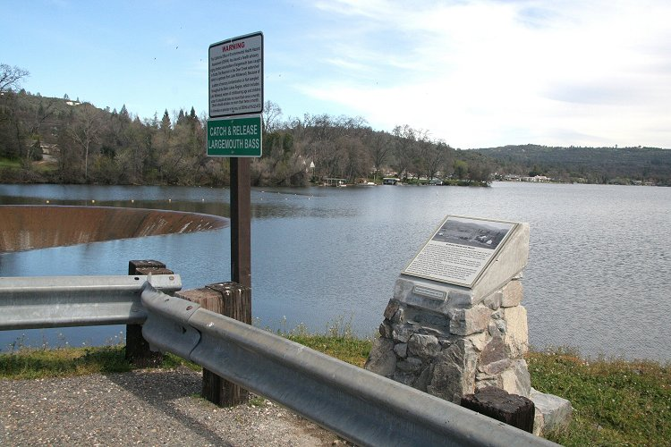
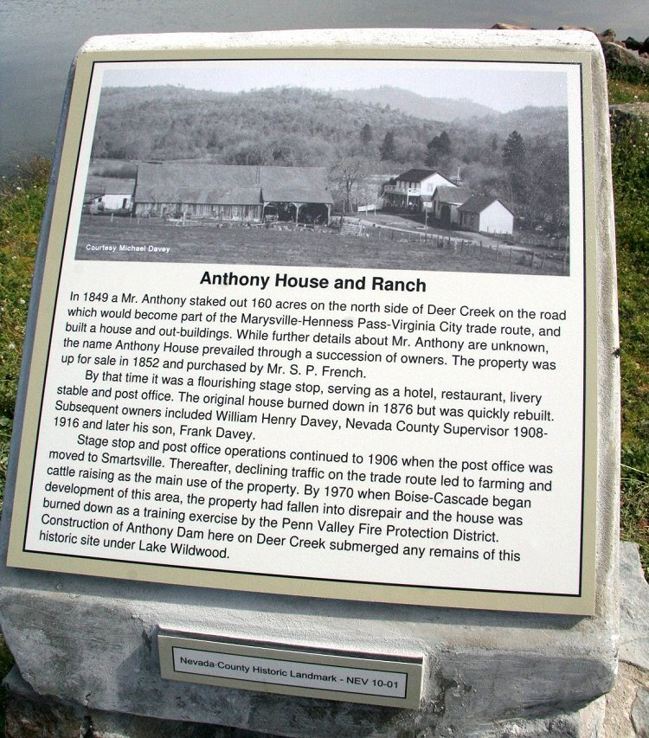
In Remembrance of Patty Pauly
Patty passed away peacefully Feb 7, 2010 in Grass Valley, California following a massive brain hemorrhage. She was born Mary Patricia Duemler June 22, 1936 in Pasadena, California, and attended Pasadena city schools. She earned a B.A. degree in music and a secondary teaching credential from Occidental College in 1957, and a M.A. degree in music education from Stanford University in 1958. Her lifelong passion was music, for which she had great talent. Beginning at age 4-1/2, Patty began to study and perform on a series of instruments including the accordion, piano, pipe organ and flute. She was interested in music as therapy and played as a volunteer at numerous care facilities over the years. In Penn Valley, she was active in the Lake Wildwood Little Theater and Yacht Club. Survivors include her husband of 52 years, Steve, son Bruce, daughter-in-law Amy, and grandchildren Dale and Claire. She was predeceased by her daughter, Mary Lynn. Memorial donations in Patty’s memory may be sent to the Occidental College Glee Club (1600 Campus Rd., Los Angeles, CA 90041) or to the South Yuba River Park Association, (PO Box 1658, Penn Valley, CA 95946).
Anthony House – Historic Landmark
By Newsletter Staff
Efforts of Dick Alexander, along with research partners Margie Powell, LWW resident active in several Historical Societies, and Bill Knight, LWW long-time resident and fellow 4th District representative on the Nevada County Historic Landmarks Commission; the Searles Library; oral histories; and support from many individuals, including the Editor of our Newsletter for photography and plaque design, has resulted in a commemorative plaque officially designated a Nevada County Historic Landmark by the NCHLC and Board of Supervisors, mounted by Don Pryor at the Lake Wildwood dam overlook. (See photos at left.) Dedication will take place at the site on April 23 at 11:00 am. All Docents, their families and friends and Park Staff are invited to attend.
What’s up with our Rangers?
Around the Park
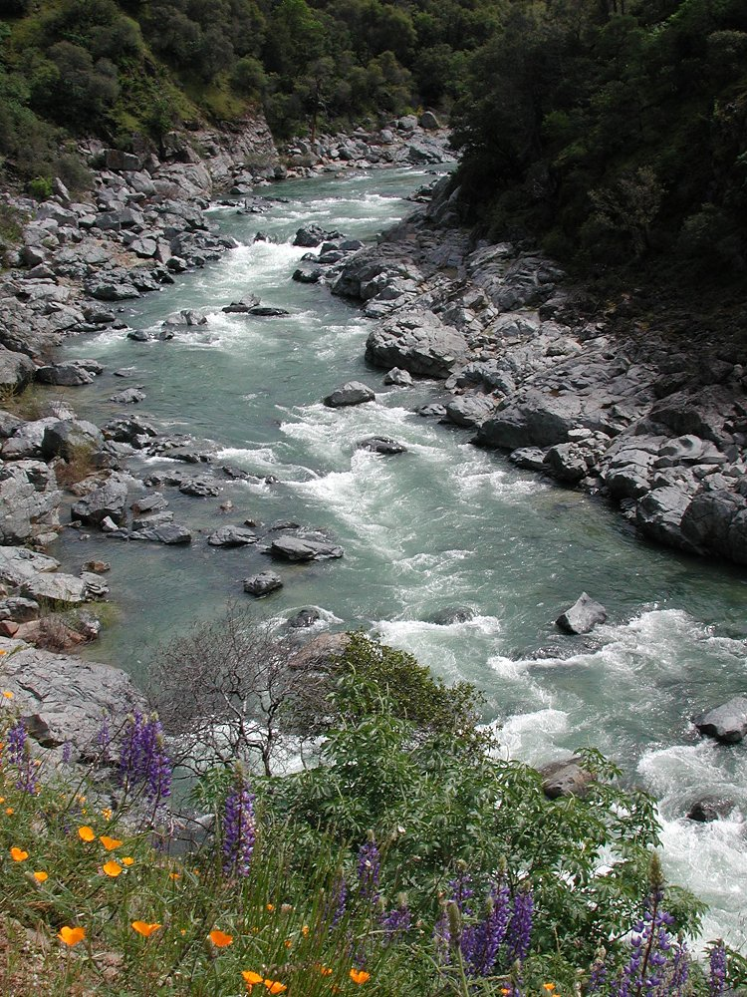
River at Buttermilk Bend Trail
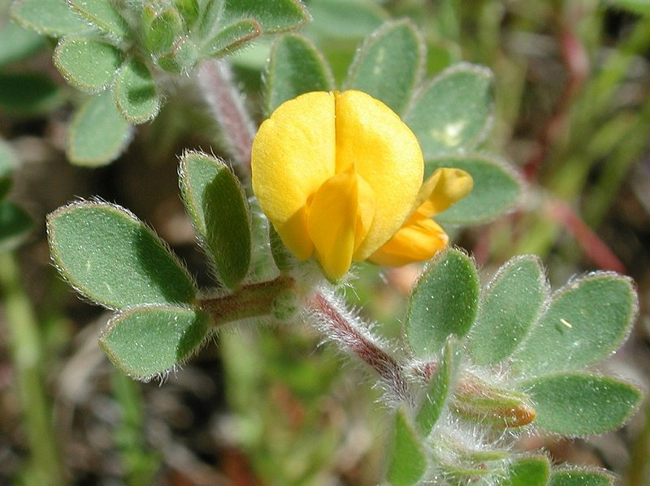
Hill Lotus close-up
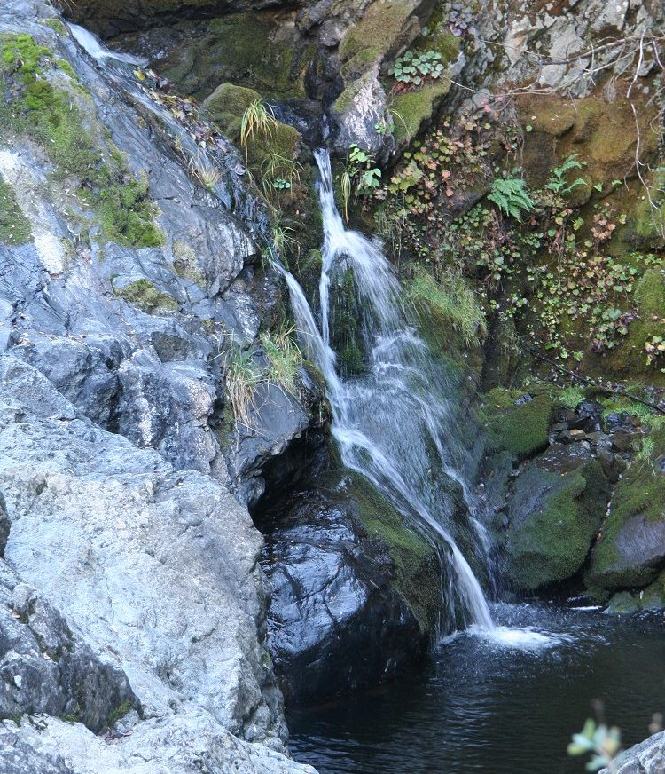
Mini waterfall near river-crossing flume on Independence Trail

Volume 2, Number 1 Page 5
By Ranger Jennifer McCallan
Having just returned from a hike on the Buttermilk Bend Trail, I can confidently state that Spring has sprung! (March 3) Most all of our early season wildflowers were showing their faces and the hillsides were a bright, verdant green. A big storm had just eased up and the sky was scrubbed clean with puffy clouds. The river and French Corral Creek were thundering mightily. Today was a good day to be outside at South Yuba River State Park. Many people would agree that Spring is their favorite time of year at the river. There are many park visitors this time of year but the atmosphere is generally peaceful and orderly, with most visitors coming mainly to enjoy the beauty of nature.
While we enjoy these days, we are already thinking ahead to summertime, when we rangers will be spending most of our time on foot patrol, keeping the peace and doing law enforcement and rescues. A particular challenge this summer is that there will be two fewer rangers that last summer. There may be more instances where we must be reactive rather that proactive, and there may be fewer chances for rangers to “double up” (patrol with a partner). As always, our priority will be public safety — both law enforcement and medical aids. The presence of docents at Bridgeport and 49 Crossing is tremendously helpful especially during these short-staffed times. The docents in the Visitor Center, greeter’s station, trails, gold panning troughs, and 49 information station, not only add to visitors’ enjoyment of the park but are also extra sets of eyes and ears. Oftentimes the presence of a gold-vested park representative is enough to deter those who might otherwise break the rules or cause trouble. Docents are often the first to learn of an emergency. Several times last year docents efficiently got word to rangers of emergency situations or called 911 and then helped direct responders. For this reason, all of you are an important part of keeping this park a safe place.
As for the two rangers who we are missing, Ranger Wayne Deese reports that he is enjoying retirement, cross country skiing, and some travel. Wayne will return for a day in March to teach the new docents a class on geology. Ranger Jeremy Alling has accepted a position at another State Park, Carnagie State Vehicular Recreation Area near Livermore. Originally, Jeremy expected he would transfer around the end of January, but we have been lucky enough to keep him here at the river for an extra several weeks. We anticipate Jeremy will be transferring around mid-March and he is looking forward to patrolling on motorcycles! We will certainly miss him around here and wish much luck to him and his growing family.

Association Website
Don’t forget to check in periodically at our South Yuba River Park Association website, and tell your friends:
http://www.southyubariverstatepark.org/index.html
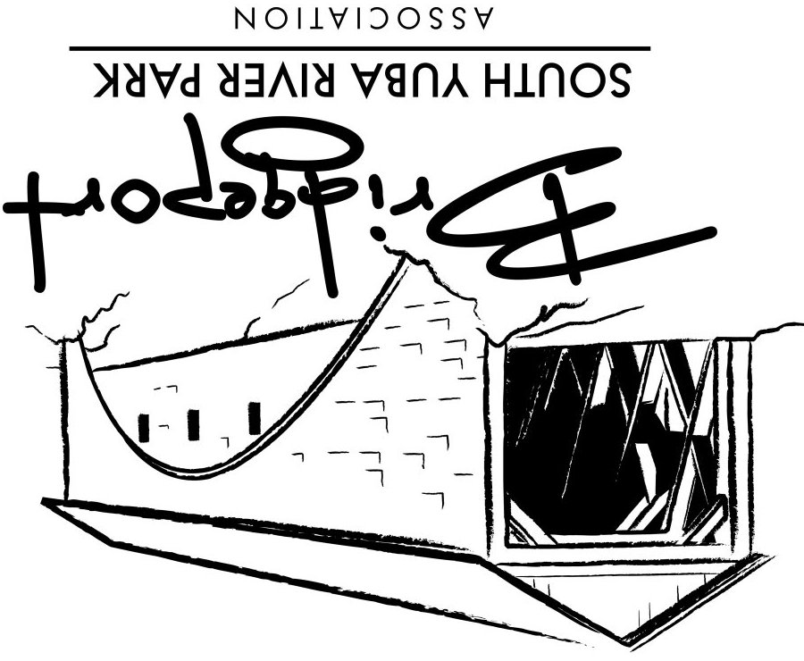
South Yuba River Park Association
17660 Pleasant Valley Road
Penn Valley, CA 95946

